Assignment 6: SQL Aggregation, Filtering & Conditional Classification

Answer 1.

- Create Table
Business Use:
Creating this table allows businesses to systematically store and manage customer order data. This structured data helps in tracking sales, analysing customer behavior, and making informed business decisions.
- Insert Data
Business Use:
Inserting data into the table allows businesses to maintain transaction records. This data is essential for
- Sales Analysis
- Inventory Management
- Customer Insights
- Financial Reporting

Screenshot – 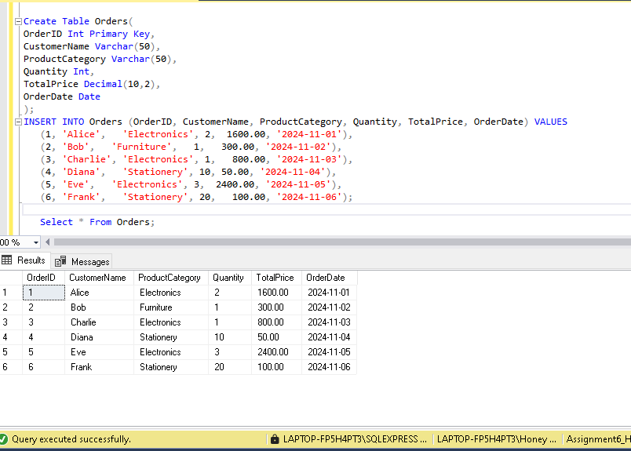

Answer 2. SQL Query Tasks

- A) Total Quantity By Category –

Explanation:
This query uses the SUM() function along with GROUP BY to calculate the total quantity of products sold in each category.
- SUM(Quantity) adds all quantities
- GROUP BY ProductCategory groups results per category

Business Use:
This helps businesses identify which product categories are in high demand. For example, if electronics has the highest quantity sold, the company can increase stock levels or focus marketing efforts on that category.

Screenshot - 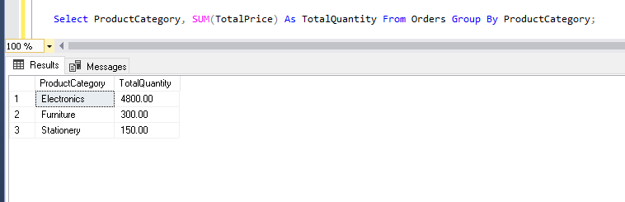

- B) Category with High Sales Volume –

Explanation:
This query filters categories where the total quantity sold is greater than 10 using a subquery.
- First, total quantity is calculated per category
- Then, only categories with TotalQuantity > 10 are selected
Business Use:
This helps businesses quickly identify high-performing product categories. These categories may require more inventory, faster restocking, or promotional campaigns to maximize revenue.

Screenshot-
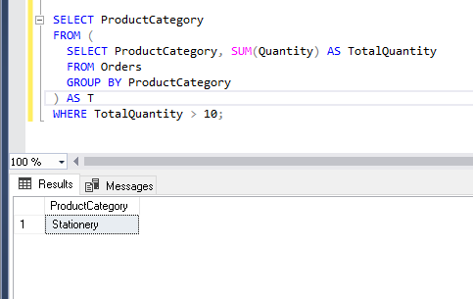

- C) Average Order Value By Category –

Explanation:
This query calculates the average order value for each product category using the AVG() function.
- AVG (TotalPrice) calculates the average price
- GROUP BY separates results per category
Business Use:
This helps businesses understand customer spending patterns across categories. Categories with higher average order values may indicate premium products and can be targeted with upselling strategies.

Screenshot-
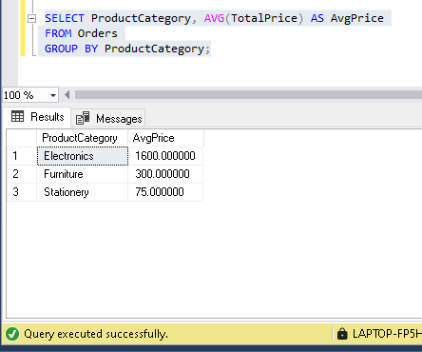

- D) Categories with Low Average Price –

Explanation:
This query identifies product categories where the average order value is less than 1000.
- Uses a subquery to calculate averages
- Filters results using WHERE AvgPrice < 1000

Business Use:
This helps businesses identify budget friendly categories. These categories are useful for attracting price-sensitive customers and running discount campaigns.

Screenshot –
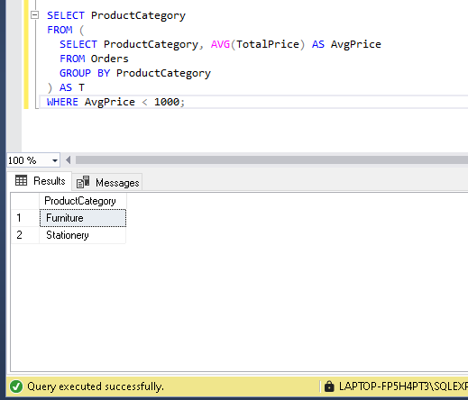

- E) Conditional Classification –

Explanation:
This query uses a CASE statement to classify each order based on its total price.
- Orders above 10000 – High Value
- Orders below or equal to 1000 – Low Value

Business Use:
This classification helps businesses segment customers into high-value and low-value groups. High-value customers can be targeted with loyalty programs, exclusive offers, or personalized marketing.

Screenshot- 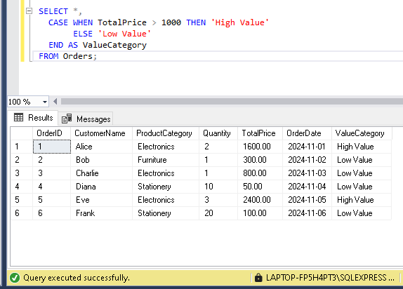

Conclusion

This assignment demonstrates the use of SQL for data Analysis through aggregation, filtering, sorting, and conditional classification. These techniques are essential for transforming raw data into meaningful insights that support business decision-making, such as identifying high-decision-making, such as identifying high performing products, understanding customer behavior, and improving sales strategies.

THANK YOU

